Q 1. Which of the following is used to take user input in Python?
A) scanf()
B) input()
C) gets()
D) cin

Q 2. What is the output of the following code?
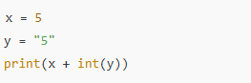
A) 55
B) 10
C) Error
D) '55'

Q 3. Which data type is mutable in Python?
A) Tuple
B) List
C) String
D) Integer

Q 4. What is the output of:
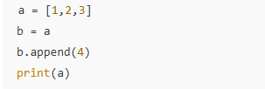
A) [1,2,3]
B) [1,2,3,4]
C) [4]
D) Error

Q 5. What is the output of print(bool([]))?
A) True
B) False
C) None
D) 0

Q 6. Which function converts string to lowercase?
A) to_lower()
B) lower()
C) str.lower()
D) make_lower()

Q 7. What will range(5) return?
A) [0,1,2,3,4,5]
B) [0,1,2,3,4]
C) [1,2,3,4,5]
D) Error

Q 8. What is the output of:
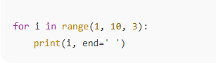
A)1 2 3
B) 1 4 7
C) 1 3 5 7 9
D) 3 6 9

Q 9. What is the data type of the following in Python?
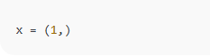
A)int
B) list
C) tuple
D) set
Q 10. Which statement is true about Python?
A) It is a compiled language
B) It is an interpreted language
C) It is written in Java
D) It does not support OOP

Q 11. What is the correct way to import NumPy?
A) import numpy as np
B) import np as numpy
C) include numpy
D) use numpy

Q 12. Which function creates an array from 0 to 9?
A) np.array(0,9)
B) np.arange(10)
C) np.arange(0,9)
D) np.zeros(9)

Q 13. Output of np.zeros((2,3)) is an array of shape:
A) (3,2)
B) (2,3)
C) (6,)
D) (2,2,3)

Q 14. What does np.eye(3) create?
A) A diagonal matrix
B) A zero matrix
C) An identity matrix
D) A random matrix

Q 15. Which function returns random numbers between 0 and 1?
A) np.random.rand()
B) np.random.randomint()
C) np.random.range()
D) np.random.float()

Q 16. What is the result of:
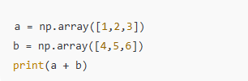
A) [5,7,9]
B) [14]
C) [1,2,3,4,5,6]
D) Error

Q 17. What is the output of np.arange(6).reshape(2,3)?
A) 2x3 matrix
B) 3x2 matrix
C) 6x1 matrix
D) Error

Q 18. Which attribute gives the number of dimensions?
A) arr.ndim
B) arr.shape
C) arr.size
D) arr.dim()

Q 19. What does arr[1:, :-1] represent?
A) All rows except first, all columns except last
B) First row only
C) First and last row only
D) Full array

Q 20. Output of:
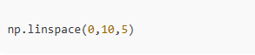
A) [0,2.5,5,7.5,10]
B) [0,5,10]
C) [1,2,3,4,5]
D) [0,2,4,6,8,10]
Q 21. Which data structure in pandas is 1-dimensional?
A) Series
B) DataFrame
C) Panel
D) Array
Q 22. Which method reads a CSV file?
A) pd.import_csv()
B) pd.read_csv()
C) pd.read()
D) pd.load_csv()

Q 23. What does df.shape return?
A) Total number of elements
B) (rows, columns)
C) Data types
D) Column names

Q 24. How to view top 3 rows?
A) df.head(3)
B) df.top(3)
C) df.first(3)
D) df.start(3)

Q 25. Which method drops rows with NaN values?
A) df.delete_na()
B) df.remove_na()
C) df.dropna()
D) df.omit_na()

Q 26. What is the output of df['A']?
A) A Series
B) A DataFrame
C) A NumPy array
D) A list

Q 27. Which command gives mean of all numeric columns?
A) df.mean()
B) df.average()
C) df.describe()
D) df.stat()

Q 28. How to get unique values in a column?
A) df['col'].unique()
B) df['col'].distinct()
C) df['col'].values()
D) df['col'].diff()

Q 29. What does df.iloc[2] return?
A) 2nd row
B) 3rd row (by position)
C) 2nd column
D) All rows except 2

Q 30. To group data by a column use:
A) df.aggregate('column')
B) df.groupby('column')
C) df.group('column')
D) df.sum('column')
Q 31. What is slicing used for?
A) Adding elements
B) Removing elements
C) Extracting parts of a sequence
D) Sorting a list

Q 32. What is the output of:
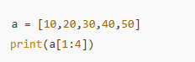
A) [10,20,30]
B) [20,30,40]
C) [30,40,50]
D) [10,30,50]

Q 33. What does a[::-1] do?
A) Sorts list ascending
B) Sorts list descending
C) Reverses list
D) Removes last element

Q 34. Output of a[:3] when a=[1,2,3,4,5]?
A) [1,2,3]
B) [1,2,3,4]
C) [2,3,4]
D) [3,4,5]

Q 35. Output of a[-2:] when a=[10,20,30,40]?
A) [10,20]
B) [20,30]
C) [30,40]
D) [40]

Q 36. What does arr[0, :] return in NumPy?
A) Entire first row
B) Entire first column
C) Last row
D) Diagonal elements

Q 37. What does arr[:, 1] return?
A) Entire first column
B) Entire second column
C) Entire second row
D) Diagonal elements

Q 38. What will be the output of the following code?
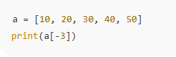
A) 10
B) 20
C) 30
D) 40

Q 39. What does df.loc[2, 'Name'] return?
A) The value at index 2 and column Name
B) The 2nd row
C) The entire column Name
D) The entire row 2

Q 40. Which of the following data structures does not allow duplicate elements?
A) List
B) Tuple
C) Set
D) Dictionary

